LC-2102a
2U CubeSat Structure
Production Guide

Document change log
Rev. | Date | Author | Pages | Description
0 | 2014-07-11 | Artur Scholz | All | Initial release

Table of Contents
1 Introduction 3
2 Hardware 3
2.1 Hardware preparation 3
2.2 Assembly overview 4
2.3 Component assembly 5
2.4 Product assembly 6

Introduction
This document provides the necessary information for production and assembly of the product as shown in Illustration 1

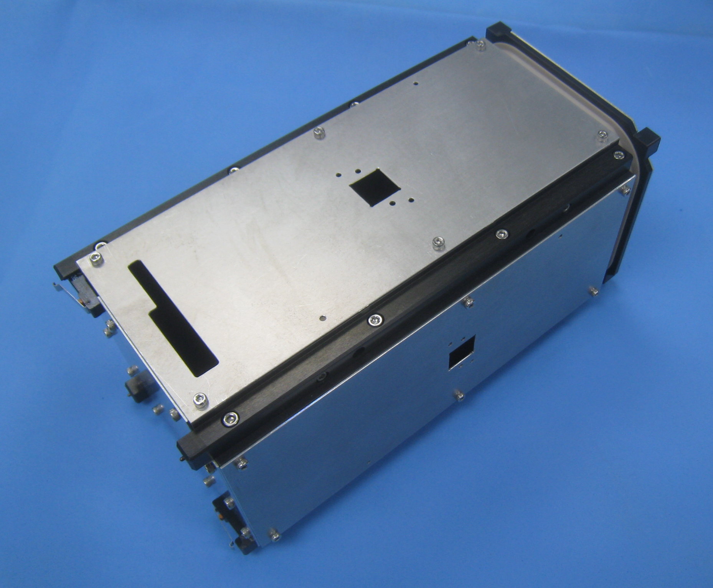Illustration 1: Fully assembled product

Hardware

Hardware preparation
The product consists of mechanical parts, screws, a few other components, and a PCB for the antenna deployment mechanisms.

Structural parts and the PCB must be manufactured, using the information provided in the product package. Screws and the components can be bought off the shelf.

Assembly overview
Prepare a clean, bright, spacious and flat work desk for the assembly. When doing the flight integration of other satellite parts (in particular the electronic systems) ensure ESD protection and adherence to cleanliness requirements. Prepare all parts, screws, tools and put in convenient reach.

Do not use excessive force when mounting the screws. Recommended values for bolt torque (according to VDI 2230) are shown in Table 1.

Table 1: Recommended bolt torques
Thread | M2 | M2.5 | M3
Bolt torque [Nm] | 0.36 | 0.73 | 1.3

Parts
2x Frame A
2x Frame B
1x Frame C
1x Antenna Ring
1x Front Panel (Panel 1)
3x Side Panel (Panel 2)
1x Top Panel (Panel 5)
1x Bottom Panel (Panel 6)
8x Mounting Blocks (2x FLU, 2x FRU, 1x BRU, 1x BLU, 1x BRD, 1x BLD)
2x Separation Springs
2x Deployment Switches

Screws
4x M2x10 Hexagon socket head screw
16x M2.5x5 Hexagon socket head screw
16x M3x10 Hexagon socket head screw
10x M3x16 Hexagon socket head screw
44x M2.5x4 Hexagon socket head screw

Tools
Hex key screwdriver 1.5 mm for M2 hex socket screws
Hex key screwdriver 2 mm for M2.5 hex socket screws
Hex key screwdriver 2.5 mm for M3 hex socket screws

Component assembly
The following sections describe the preparations that shall be carried out before the stand-alone integration.

Assembly of Frame A
The preparation of each Frame A is identical. See Illustration 2 and Illustration 3 for details.

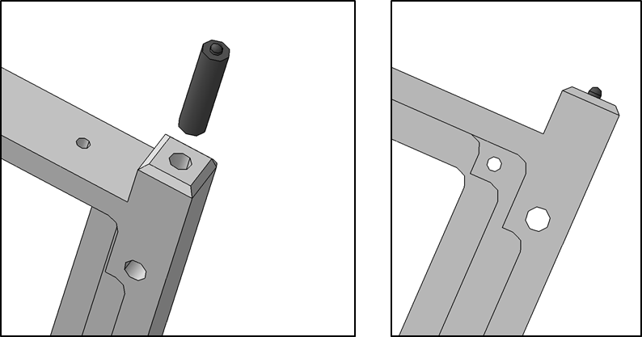Illustration 2: Screw the Separation Spring into the frame until only the tip shows out
 | It is recommended to apply screw lock (such as Loctite) to permanently fix the Separation Spring onto the frame.

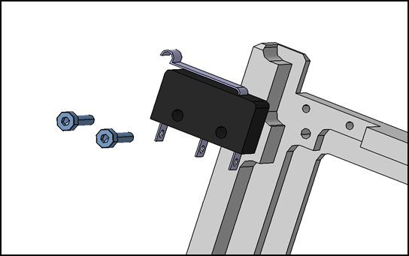Illustration 3: Screw the Deployment Switch to the frame with 2x M2x10 screws

Product assembly
Ensure that each Frame A has been prepared according to the instructions given in the previous section. Although both are identical, one shall be declared as the front frame (in -X direction). (Later during the integration this front frame will be equipped with the front panel.)

Take the Frame A that is designated as the front frame. Mount Frame B to Frame A with 4x M3x10 screws (Illustration 4). Do not fasten the screws tightly and allow for some play. Mount the other Frame B to Frame A with 4x M3x10 screws. Again, do not fasten the screws tightly and allow for some play.

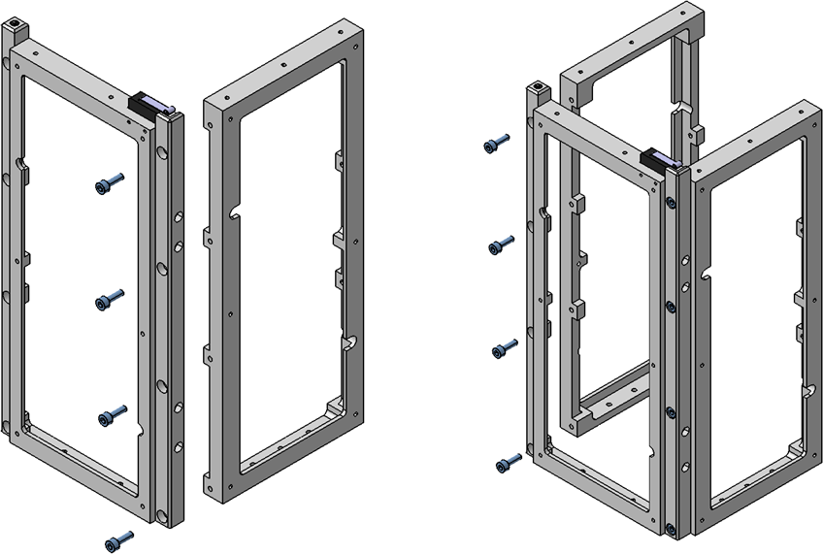Illustration 4: Mount both Frame B to Frame A
Up

Front Right

Mount the other Frame A to the assembly with 8x M3x10 screws (Illustration 5). Do not fasten the screws tightly and allow for some play.

Erect the assembly on a flat surface in upright position, ensure that the frame is aligned correctly, and fasten all screws. When tightening the screws proceed in a cross-wise fashion and start from inside and then mount outside screws (Illustration 6).

Up

Front Right
2
3
7
6
4
5
8
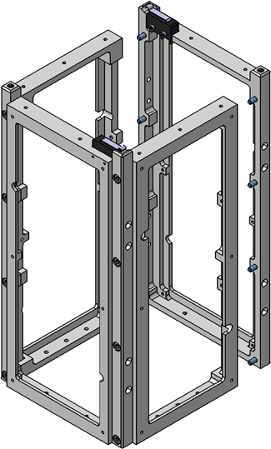Illustration 5: Mount remaining Frame A to assembly
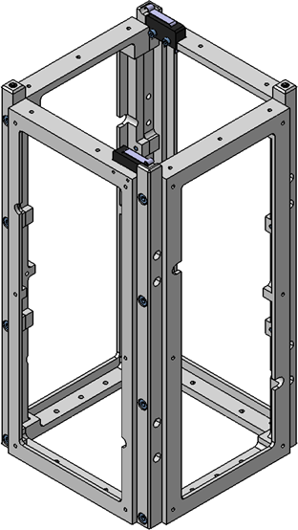Illustration 6: Tighten the screws cross-wise
1
Mount Antenna Ring and Frame C loosely onto the assembly using 10x M3x16 screws (Illustration 7). Align all rail surfaces and fix screws cross-wise (Illustration 8).

Align all surfaces
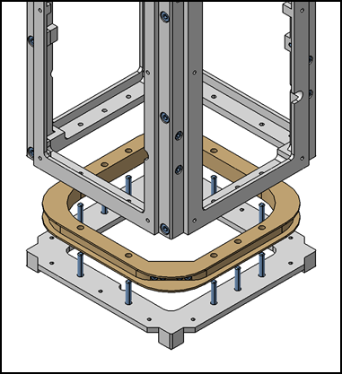Illustration 7: Mount Antenna Ring and Frame C to assembly
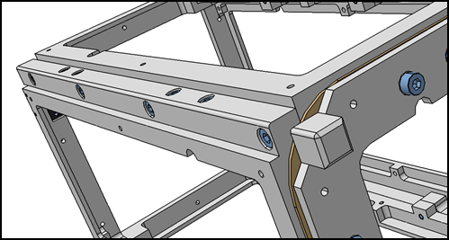Illustration 8: Align rails before tightening the screws
With the frame being assembled, the mounting blocks can now be installed. These blocks are used for mounting the internal boards during the satellite integration.

Each mounting block is installed with an M2.5x5 screw. The naming of the blocks corresponds to their position within the frame and is according to the following convention: [F(ront)/B(ack)][R(ight)/L(eft)][U(p)/D(own)].

BLU

FLU
BRU

FRU

BLD

FLD=FRU
BRD

FRD=FLU
Then mount the Top Panel (Panel 5) with 10x M2.5x4 screws (Illustration 12). Mount Bottom Panel (Panel 6) with 10x M2.5x4 screws (Illustration 11). When mounting, observe the orientation of the panel to match the openings (as used for the solar cell harness).
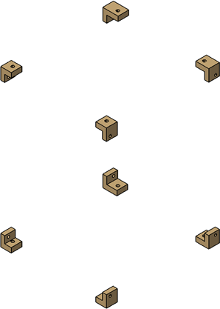Illustration 10: Mounting blocks
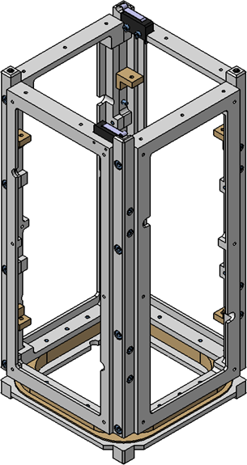Illustration 9: Mounting blocks on place

Align openings
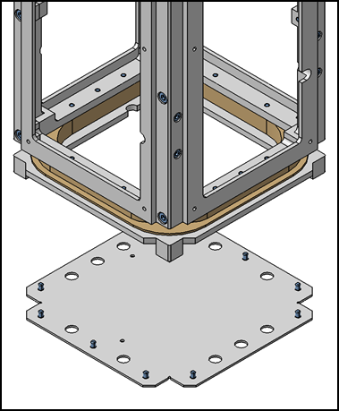Illustration 11: Mount Bottom Panel
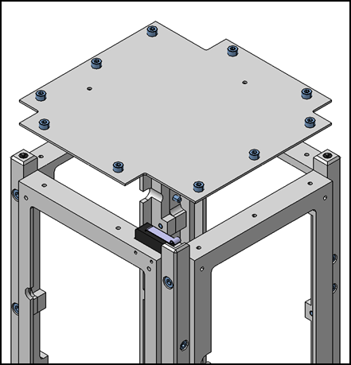Illustration 12: Mount Top Panel
Mount all side panels, each with 6x M2.5x4 screws, with the Front Panel on the designated front frame. For each panel, pay attention to match the openings, and align the side panels when mounting.

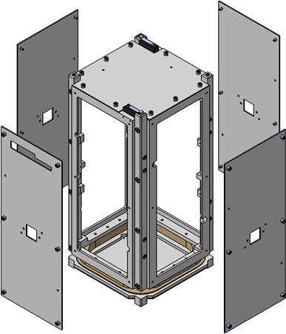Illustration 13: Mount Side Panels
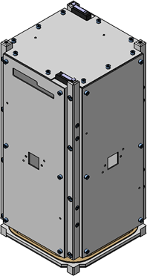Illustration 14: Finished assembly

